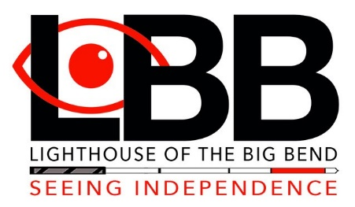
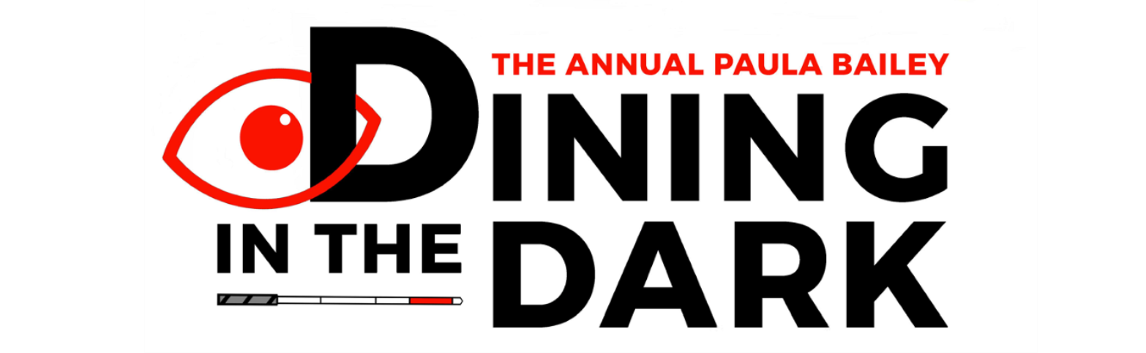
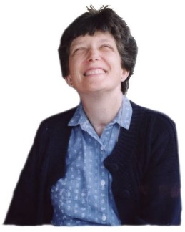
16th Annual Paula Bailey
Inspirational Community Member Award
Nomination Form

Paula Bailey was a beloved Tallahassee resident who became blind and deaf after contracting meningitis in 1999. Despite receiving this difficult diagnosis after being in a coma for several weeks, she persevered. After reaching out to LBB for assistance, she was able to learn how to navigate and maintain a fulfilling life through orientation, mobility, adjustment, self-advocacy counseling, and learning valuable communication skills. Unfortunately, in 2005 we lost this inspiring woman when she was killed in an automobile accident on her way to represent and bring awareness to blind individuals and march in the Springtime Tallahassee Grand Parade. Paula remains an inspiration to all of us at LBB. It was a privilege to have known Paula and to honor her every year with this event.

Every year prior to our Annual Dining in the Dark and announcing the award recipient, LBB invites our community to send us their nomination for the award. The ideal individual will be inspirational in a community we represent because of their positive attitude and their ability to learn the necessary skills to adjust, advocate for themselves, and live a fulfilling and independent lifestyle.

LBB’s Award Committee reviews and selects the award recipient which is announced and presented LBB’s Annual Paula Bailey Dining in the Dark event on Saturday, January 23, 2021.

Please note LBB must receive nomination forms no later than December 31, 2020.

Qualifications:
- Visually impaired or blind (from birth or later in life)
- A resident of one of the 11 counties LBB serves (Franklin, Gadsden, Hamilton, Jefferson, Lafayette, Leon, Liberty, Madison, Suwannee, Taylor or Wakulla)
- An individual who has not received the award in the past 10 years*
- Individual’s personality reflects the same inspiring characteristics of Paula Bailey including a positive attitude, and the desire and determination to learn the necessary skills to adjust and live a full and independent lifestyle.

Please email the completed form to: djump@seeingindependence.org
*Past winners include: Ronald Fox, John Plescow, Lloyd Blackwood, Jr, Owen McCaul, Norine Labitzke, Michael Elliot, William Benjamin, Barbara Kiger, Delores Wussler, and Dexter “Chip” Orange.

16th Paula Bailey Inspirational Community Award
Nomination Form

Nominator Name _____________________________________________
Street Address ______________________________________________
City __________________________ State ______ Zip Code _________
Phone _________________ Email ______________________________

Nominee Name ______________________________________________

Street Address _______________________________________________

City ______________________ State _______ Zip Code ___________

Phone ___________________ Email ___________________________

Is the nominee blind or visually impaired? __________

At what age did the nominee become blind or visually impaired? _______

Please explain how the nominee became blind or visually impaired? ____________________________________________________________
____________________________________________________________
Please describe in detail why you are nominating this individual and give examples of the characteristics which make your nominee an inspiration to their community.
____________________________________________________________
____________________________________________________________

____________________________________________________________
____________________________________________________________

